**Brainstorm**

**& idea prioritization**

Use this template in your own brainstorming sessions so your team can unleash their imagination and start shaping concepts even if you're not sitting in the same room.

**Before you collaborate**

A little bit of preparation goes a long way with this session. Here’s what you need to do to get going.

**10 minutes**

1. **Team gathering**

Define who should participate in the session and send an invite. Share relevant information or pre-work ahead.

1. **Set the goal**

Think about the problem you'll be focusing on solving in the brainstorming session.

1. **Learn how to use the facilitation tools**

Use the Facilitation Superpowers to run a happy and productive session.

Providing accurate data- driven forecasts in real time for changing the retail store.

**1**

#### Define your problem statement

What problem are you trying to solve? Frame your problem as a How Might We statement. This will be the focus of your brainstorm.

**5 minutes**

**2**

#### Brainstorm

Write down any ideas that come to mind that address your problem statement.

**10 minutes**

**MOHAMMED MUZAKEER.M**

Collecting the stock record and analyzing over the records.

With the help of IBM Cognos Analytics,creating a dashboard to visualize the data.

**PROBLEM**

The goal is to identify the Retail Store Stock to predict the availability of stock which can be under a risk condition to avail the product.The retail stock are identified based on the 0- 100 days stock to predict the next 100 days based on the environment and people's mentality

**TIP**

You can select a sticky note and hit the pencil [switch to sketch] icon to start drawing!

**JANANI.R**

Enhancing data collaboration and innovation among retail store.

Earlier detection of environment and make prevention over the stock.

**3**

#### Group ideas

**4**

**Prioritize**

Your team should all be on the same page about what's important moving forward. Place your ideas on this grid to determine which ideas are important and which are feasible.

**20 minutes**

Take turns sharing your ideas while clustering similar or related notes as you go. Once all sticky notes have been grouped, give each cluster a sentence-like label. If a cluster is bigger than six sticky notes, try and see if you and break it up into smaller sub-groups.

**20 minutes**

Understanding the historical trends and determinig what to explore next.

increasingly emphasize prediction and prevention over response and stock.

Improving stock documentation for future reference.

# TECHNICAL IDEAS..

With the help of IBM Cognos Analytics,creating a dashboard to visualize the data.

Deliver real-time

alerts to healthcare Collectin

providers by patients re

analyzing health

data at the and analy

collection point. over th

record

**Importance**

If each of these

done without any Understanding

tasks could get

difficulty or cost,

which would have the historical

the most positive

impact? trends and

determinig what to explore next.

Enhancin collabor and inno

amo health organiz

**Feasibility**

Regardless of their importance, which tasks are more feasible than others? (Cost, time, effort, complexity, etc.)

**TIP**

Add customizable tags to sticky notes to make it easier to find, browse, organize, and categorize important ideas as themes within your mural.

**10 minutes** to prepare

**1 hour** to collaborate

**2-8 people** recommended

[**Open article**](https://support.mural.co/en/articles/2113740-facilitation-superpowers)

Improving our stock field by adding the report generated.

**VISHAL.D**

Improve the accuracy and speed of identifying stock at highest risk of availability.

increasingly emphasize prediction and prevention over response and stock.

analytical

trends are

Understanding the historical trends and determinig what to explore next.

followed to

obtain the

clean data

## ABIRAMI.B

Improving stock documentation for future reference.

Data analytics can help practitioners predict risks of identification, analysis and readmission.

With the help of IBM Cognos Analytics,creating a dashboard to visualize the data.

Providing accurate data- driven forecasts in real time for changing stock availability.

Understanding

the historical trends and determinig what to explore next.

Data analytics in stock reduces fraud and increases security of stock record.

Collecting the

stock record and analyzing over the records.

g the cord zing e

s.

### g data ation vation ng

Data analytics can help practitioners predict risks of identification, analysis and readmission.

and personnel

Data analytics in retail stock helps the organization to identify the store stock

Smart staffing

Promote preventive measures by giving stock greater insight into their analysis and object goals.

Deliver real-time alerts to stock manager providers by analyzing stock data at the collection point.

management can be done in

# NON-TECHNICAL IDEAS.

Promote

### care ations.

[**Share template feedback**](https://muralco.typeform.com/to/CiqaHVat?typeform-source=app.mural.co)

data analytics.

preventive measures by giving stock greater insight into their analysis and object goals.

Data analytics can

help practitioners predict risks of identification, analysis and readmission.

increasingly

emphasize prediction and prevention over response and analysis.

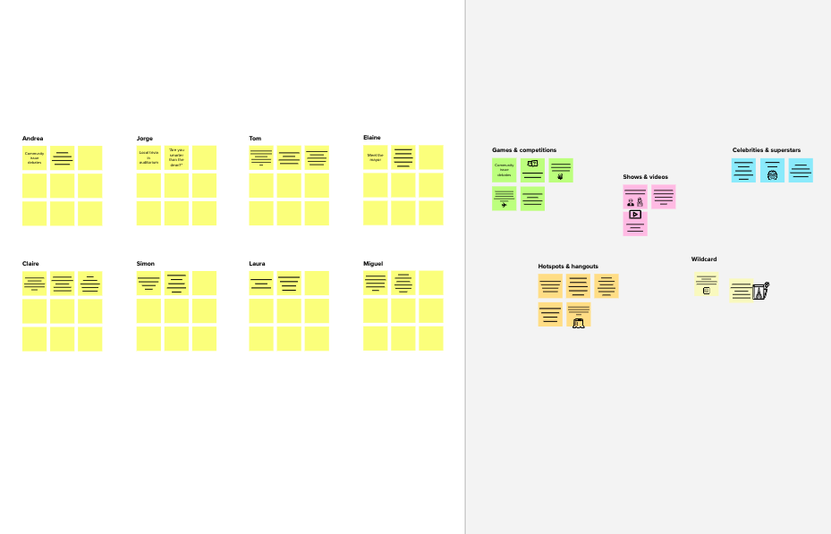

**Template**

**Need some inspiration?**

See a finished version of this template to kickstart your work.

[**Open example**](https://app.mural.co/template/e5a93b7b-49f2-48c9-afd7-a635d860eba6/93f1b98d-b2d2-4695-8e85-7e9c0d2fd9b9)